English:
During the first half term, children will be focusing on grammar skills.
They will be securing their knowledge of varying structures including using subordinate clauses and adverbial phrases to extend their ideas.

In reading, children will be focussing on fluency and test techniques so they are confident in using a range of skills to gain a deeper understanding texts when we study them
RE
Mission: Children will begin the year by learning about our school mission statement: ‘We live our lives like Jesus’.
Creation: Children will discuss how we can live as one of the people of God. They will explore scripture from Saint Paul and learn about how the Beatitudes can guide us in being a person of God.
Maths

Year 5: Children will be developing their place value knowledge of numbers up to 1 million. They will secure their understanding of formal addition and subtraction methods and begin to learn more about multiplication.

Year 6: Children will be developing their understanding of place value up to 10 million. They will learn the most efficient methods for adding and subtracting and apply this to different contexts. They will deepen their understanding perimeter and area and multiplication methods.



Spanish
In Spanish the children will learn how to describe a town and learn what places are there.

Science
Children will be answering the question: How does light enable us to see?
They will learn about how light travels, refraction and reflection and get hands-on making a periscope.

History

Children will be answering the key question: ‘Who are the ancient Maya and what should they be remembered for?’
They will learn about the Maya civilisations hierarchy, explore artifacts and inventions and look at the different gods that the Maya believed in. The children will then present their findings to each other in an attempt to answer our key question.
Year 5/6
Autumn Term 1

PSHE
Children will learn about healthy relationships and boundaries in PSHE. They will use their oracy skills to discuss, challenge and present their ideas on the topic.

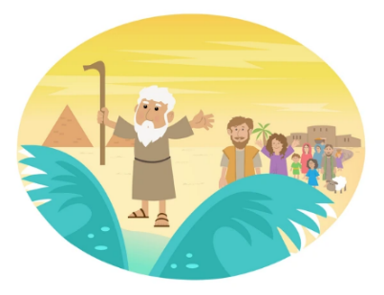
Computing
Children will learn about systems and networks, explore how search results are ranked and what the role of a ‘web crawler’ is!

Art

Children will deepen their learning about the Maya through exploring printing, line shape and pattern drawing.
PE

PE DAYS – Monday and Friday

