Maths
Year 5
Our Year 5 mathematicians will be strengthening their fluency with large numbers and complex calculations. We will begin by refining our strategies for addition and subtraction, alongside learning how to round numbers to estimate answers and check for accuracy. Children will develop their confidence in long multiplication and learn to use the inverse operation as a vital checking tool.
Year 6
Children will continue to recap the following topics:
*multiplying decimals.
*Adding and Subtracting fractions.
*Dividing fractions and decimals

RE - Lent
This half-term, our RE lessons will focus on the spiritual journey of Lent and the personal growth it inspires. By studying the Gospels, students will explore how the teachings of Jesus provide a blueprint for resisting temptation in our modern lives. We will examine the specific symbolism of Lent and discuss the true meaning of repentance—not just as an apology, but as a sincere commitment to turning our lives in a positive direction.
Furthermore, we will investigate the teachings of the apostles to understand how their guidance helps us follow in Jesus’ footsteps and overcome challenges. To conclude the unit, students will reflect on why change is the central theme of this season. We will look at how personal transformation allows us to better serve our community and find practical ways to help others during this time of reflection.

English
This half term, students will be working on a variety of writing styles to help them communicate clearly and effectively. We will begin by practicing the formal structure of letter writing before moving on to the descriptive techniques needed for engaging travel reviews.
A major focus of our work will be the development of persuasive speeches. By analysing the story of Goldilocks and using new forensic vocabulary, children will learn how to build strong arguments based on evidence. To support this, we will be integrating year 5/6 grammar and punctuation into their drafts. They will use modal verbs to express degrees of certainty and relative clauses to provide essential detail within their sentences. Additionally, they will be using colons and semi-colons to link related ideas and manage more complex sentence structures.
.


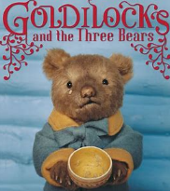

History
This half term, our history lessons will transport the children back to the 1940s as we explore the impact of World War II. Our focus will be on the experiences of evacuee children, examining the emotional and practical challenges they faced when leaving their homes for the countryside. Children will gain a deeper understanding of what life was like for young people during the Blitz.
To bring this period of history to life, we are very much looking forward to our trip to Stansted House at the end of the half term. This visit will provide a fantastic opportunity for the children to step into the shoes of an evacuee and see first-hand how grand estates and rural communities played a vital role in the war effort.

Spanish
This half term, children will be expanding their Spanish communication skills by exploring the theme of identity and origins. They will be learning how to identify various countries and nationalities, enabling them to both say and write about where they are from with confidence.
In addition to sharing their backgrounds, students will practice discussing the different languages they speak. To do this, they will be introduced to the key verb "hablar" (to speak).

Year 5/6
Spring 2

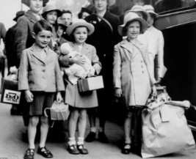

PE

PE DAYS – Monday and Friday
PSHE
This half term, our Year 5 and 6 PSHE lessons will follow the Ten Ten ‘Life to the Full’ curriculum, which provide a factual and respectful look at how our bodies change and how life begins. We will be learning about the physical and emotional changes that happen during puberty, specifically focusing on girls' bodies and boys' bodies in year 5. In year 6, our RSE will explain the biological process of how a baby is conceived and born.

