RE
Christmas
Children will focus on the question, ‘How can the circumstances of Jesus’ birth inspire our actions today?’

Revelation
Children will focus on the question, ‘How does getting to know Jesus help us know God better?’
English:
This half term, our writing will be inspired by the beautifully illustrated and thought-provoking world of 'The Lost Thing' by Shaun Tan.
Through this text, children will develop their empathy and descriptive skills by composing emotive diary entries and structured narrative recounts. In our grammar focus, students will learn to enhance their storytelling by mastering the use of direct speech, as well as employing colons and semi-colons to link complex ideas.
Additionally, we will be working on the precision of our writing by integrating fronted adverbials to create flow and provide clear detail for the reader.

Maths

Year 5
This term, pupils will practise converting between different units of measure, including length, mass, capacity, and time. They will also measure and calculate the perimeter of composite rectilinear shapes and read and interpret tables and timetables to solve practical problems.
Pupils will identify 3-D shapes from 2-D representations and develop their understanding of angles. They will estimate and compare different types of angles, recognise angles at a point, and understand that a full turn is 360°.

Year 6
Children will recap the following topics: *multiplying decimals, percentages.
*area, perimeter and volume
*BIDMAS and algebra
*Ratio
*Diving fractions and decimals

Spanish
In Spanish, children will be revising places in town and then learning about 12 modes of transport.

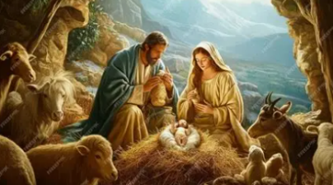
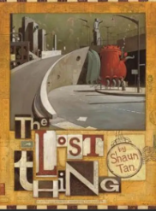
Science
In science, children will discover how living things produce offspring that are similar but not identical to their parents, forming the basis of inheritance and variation. They will learn how specific adaptations occur over time to help animals survive in their environments. Students will plan a scientific enquiry to investigate how certain physical traits, such as bird beak shapes, affect an animal's ability to thrive.

Year 5/6
Spring 1

Geography
In geography, children will be working towards answering our big question ‘How do mountains change our world’s landscape?’ Children will be able to explain how mountains are formed, identify the features of mountains, including being able to describe physical features of mountains and use OS maps to explore Mount Snowdon and the surrounding areas.
PSHE
Children will be answering the question. ‘How do I resolve conflict?’ They will explore the qualities of positive friendships and discuss how relationships naturally change as we grow older.
They will learn to identify unhealthy dynamics, including the harmful impact of bullying, discrimination, and prejudice as well as develop respectful strategies to resolve disagreements.
• By the end of the term, children will have a toolkit of skills to maintain healthy boundaries and navigate social challenges.

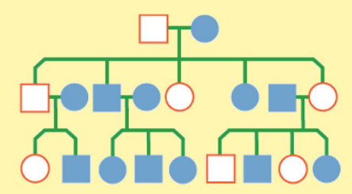
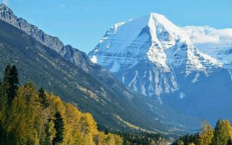

Art
In art, children will on perspective and painting by learning how to draw landscapes.
PE

PE DAYS – Monday and Friday

