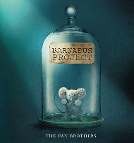
Writing
This half term we will using the Barnabus Project by the Fan Brothers as our writing stimulus. We will be exploring non-chronological reports, creating our own and designing our own ‘failed project’ to inspire our writing. Children will also explore writing skills across the curriculum, focusing on persuasion to link to our geography project as well.
Reading
We will continue to improve our reading fluency and engagement this term as well as starting to explore texts through destination reader lessons to support us in our learning. Every day we practise reading different genres and types of texts including, poems , instructions, speeches and play scripts.

Religious Education

Catholic Social Teaching
We will be answering the question: Who are the marginalised and how can they be included?

Advent
We will be answering the question: How does John the Baptist help us prepare during Advent?
Maths
Year 5: Children will learn about: Multiplication and division.
Year 6 : Children will learn about: Multiplication and division.

We will focus on building skills using concrete resources, then move to pictorial representations, ready for children to be able to solve abstract calculations and problems.



Geography
The children will become ‘City Planners’ as they explore what makes places a great community to live in. They’ll look at maps, learn how cities are organised, and think carefully about transport, green spaces, and buildings. Using what they’ve learnt, the children will design their own city and present ideas — hopefully to a local councillor!

Science
We will be exploring Electricity!

Children will learn How circuit components and voltage impact how each component functions. They will learn to recognise different electricity symbols and how to design their own circuits.

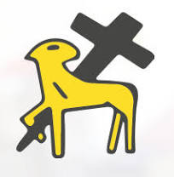
Year 5/6
Autumn Term 2

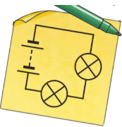
PSHE
In PSHE we will focussing on Mental Health and wellbeing.
Children will know that mental health, just like physical health, is part of daily life. Children will learn to identify emotions and develop strategies that support mental health.

Art / DT
During DT lessons, children will be learning about mechanisms as they design and construct moving vehicles. They will investigate how wheels, axles, and chassis function, then apply this knowledge to create their own working models.
Music:
In our music lessons this half term we continue to read and write music using drums.
We will also be developing our singing skills by using our voices to explore songs,
rhymes and chants.
We look forward to showcasing
our skills during our Carol services in
December.

Computing
We will exploring how to create media.
Children will learn to explain what makes a video effective. Identify digital devices that can record video and create a storyboard, record and edit a project.

USEFUL DATES :
Thursday November 13th – Michael Rosen Day
Thursday November 13th – Year 6 Kindness Day Sale
Monday 1st December – INSET Day

Please support your children to complete the following homework:
Spelling: Issued on a Friday, due for return the following Friday.
Reading: Children should read daily at home, but MUST read 3 times weekly. Diaries are checked on
Fridays. Maths homework is checked on Fridays by maths teachers. Spellings should also be completed.
Children are rewarded with merits on completion of each homework. Homework is a key way for
children to practise key skills.
PE
Our PE days will be Monday and Friday.
Full PE uniform should be worn.



